


Project Report

on
Smart Camera Observation & Unusual Tracking System (SCOUT)

submitted as partial fulfillment for the award of

BACHELOR OF TECHNOLOGY
DEGREE
SESSION 2025-26
in
Computer Science Engineering (Artificial Intelligence & Machine Learning)

By

Satyam Singhal (2200291530098)

Ujjwal Dwivedi (2200291530123)
Rohit Verma (2200291530087) Under the supervision of Dr. Laxman Singh
KIET Group of Institutions, Ghaziabad

Affiliated to
Dr. A.P.J. Abdul Kalam Technical University, Lucknow
(Formerly UPTU)
May, 2026

DECLARATION
We hereby declare that this submission is our own work and that, to the best of our knowledge and belief, it contains no material previously published or written by another person nor material which to a substantial extent has been accepted for the award of any other degree or diploma of the university or other institute of higher learning, except where due acknowledgment has been made in the text.

Signature Of Students

Satyam Singhal (2200291530098)

Ujjwal Dwivedi (2200291530123)

Rohit Verma (2200291530087)

Date:



CERTIFICATE

This is to certify that Project Report entitled “Smart Camera Observation & Unusual Tracking System (SCOUT)” which is submitted by Satyam Singhal, Ujjwal Dwivedi, Rohit Verma in partial fulfillment of the requirement for the award of degree B. Tech. in Department of CSE (AIML) of Dr. A.P.J. Abdul Kalam Technical University, Lucknow is a record of the candidates own work carried out by them under my supervision. The matter embodied in this report is original and has not been submitted for the award of any other degree.

Dr. Laxman Singh Dr. Rekha Kashyap

Prof – CSE (AI/AIML) Dean – CSE (AI/AI&ML)

Date:

ACKNOWLEDGEMENT

It gives us a great sense of pleasure to present the report of the B. Tech Project undertaken during B. Tech. Final Year. We owe special debt of gratitude to Dr. Laxman Singh, Department of CSE(AIML), KIET, Ghaziabad, for his constant support and guidance throughout the course of our work. His sincerity, thoroughness and perseverance have been a constant source of inspiration for us. It is only his cognizant efforts that our endeavors have seen light of the day.
We also take the opportunity to acknowledge the contribution of Dr. Rekha Kashyap, Dean of the Department of Computer Science & Engineering (AI/AI&ML), KIET, Ghaziabad, for his full support and assistance during the development of the project. We also do not like to miss the opportunity to acknowledge the contribution of all the faculty members of the department for their kind assistance and cooperation during the development of our project.
We also do not like to miss the opportunity to acknowledge the contribution of all faculty members, especially faculty/industry person/any person, of the department for their kind assistance and cooperation during the development of our project. Last but not the least, we acknowledge our friends for their contribution in the completion of the project.

Date:

Satyam Singhal (2200291530098)

Ujjwal Dwivedi (2200291530123)

Rohit Verma (2200291530087)

ABSTRACT

Smart home security systems are usually concerned with the detection of intrusion, yet they usually overlook other important safety issues like fall detection of aged people and early detection of fire outbreaks. The existing solutions also involve significant consumption of wearable devices or cloud-based monitoring systems, which can contribute to the difficulty of using them, risk of privacy, and slow responsiveness. These constraints make it clear that a smarter, non-invasive, and privacy-conscious monitoring system with the ability to identify various emergency cases in real time is necessary.
The presented project proposes an artificial intelligence-powered home surveillance system named SCOUT (Smart Camera Observation and Unusual Tracking System), which requires a combination of real-time surveillance, human movement, and detection of emergencies using computer vision and advanced machine learning systems. It refers to a system that identifies intrusions, human falls, and fire hazards through video analysis, which is recorded by surveillance cameras. .
Another crucial feature of SCOUT is the fact that it has an edge-based processing architecture whereby it enables the processing of video feed on edge devices as opposed to relying on the cloud infrastructure extensively. The design has a great impact on reducing the time to latency, improving the response time and privacy of the user, as little video information is passed to the internet. The system also generates realtime notifications and alerts to the mobile devices of the user whenever any abnormal activity or emergencies are identified so as to take immediate action.
SCOUT will also be non-invasive and user-friendly, and it will not need to wear sensors or do it manually. The suggested system proves that it is possible to implement an efficient, scalable, and privacy-friendly AI-based surveillance system that can be used in smart houses, elderly care facilities, and other areas with high security. Academic research and innovation of the project have also taken place with a research publication and published Indian patent on the basis of the SCOUT system.

TABLE OF CONTENTS Page No.
DECLARATION……………………………………………………………………. ii
CERTIFICATE……………………………………………………………………… iii
ACKNOWLEDGEMENT..…………………………………………………………. iv
ABSTRACT………………………………………………………………………..... v
LIST OF FIGURES…………………………………………………………………. viii
LIST OF TABLES…………………………………………………………………… ix
LIST OF ABBREVIATIONS………………………………………………………. x
CHAPTER 1 (INTRODUCTION)…………………………………………………. 1-2
  - Introduction……………………………………………………………………... 1
  - Project Description……………………………………………………………… 1-2
CHAPTER 2 (LITERATURE RIVIEW)…………………………………………. 3-6
  - Introduction …… …………............................................................................. 3
  - Traditional Surveillance System ........................................................................ 3-4
  - Wearable-Based Fall Detection System ............................................................. 4
  - Vision-Based Fall Detection System ............................................................. 4
  - AI-Based Fire & Smoke Detection ............................................................. 4-5
  - Object Detection for Security Monitoring ...................................................... 5
  - Research Gap................................................................................................... 5-6
CHAPTER 3 (PROPOSED METHODOLOGY) ….................................................. 7-18
  - Introduction ………………............................................................................. 7
  - System Architecture.......................................................................................... 7-8
  - Fall Detection using Temporal Analysis............................................................. 9-10
  - Intrusion Detection using Object Detection ...................................................... 10-11

  - Fire Detection.................................................................................................. 14-16
  - YOLO v8 Model Achitecture ................................................................................... 17
  - Alert and Notification System.............................................................................. 17-18

CHAPTER 4 (RESULTS AND DISCUSSIONS) ………………………….…… 19-25

  - Experimental Setup …………............................................................................. 19
  - Fall Detection Results ........................................................................ 19-20
  - Intrusion Detection Results............................................................. ............ 21-22
  - Fire Detection Results............................................................. ............ ............ 22-24
  - Overall System Performance............................................................. ............ 24-25
  - Discussions ...................................................... ............ ............ ............ ............ 25

CHAPTER 5 (CONCLUSION AND FUTUTRE SCOPE)……………….…… 26-27

  - Conclusion …………............................................................................. 26-27
  - Future Scope ..................................................... ................... ................... 27

REFERENCES………………………………………………………………………. 28-29
APPENDEX 1………………………………………………………………………... 30-31
PATENT AND PROOF OF SUBMISSION/ACCEPTANCE/PUBLICATION 32
RESEARCH PAPER AND PROOF OF 33
SUBMISSION/ACCEPTANCE/PUBLICATION
PLAGIARISM REPORT 34

LIST OF FIGURES

Figure No. Description Page No.
  - SCOUT Detection Pipeline 8
  - Flow of fall detection model 10
  - Flow of intruder Detection model 11
  - Intruder Detected Alert 12
  - Intruder Detection Alert message 13
  - Flow of fire detection model 15
  - Fire Hazard Alert by YOLOv8n 16
  - Photos or videos showcasing real-time detection 18
A SCOUT System Architecture 30

LIST OF TABLES

Table. No. Description Page No.
  - Fall Detection Performance 19-20
  - Intrusion Detection Performance 21
  - Fire Detection Performance 22-23
  - Overall SCOUT System Performance 24-25

LIST OF ABBREVIATIONS

Abbreviation | Full Form
AI | Artificial Intelligence
ML | Machine Learning
SCOUT | Smart Camera Observation & Unusual Tracking System
CNN | Convolutional Neural Network
LSTM | Long Short-Term Memory
YOLO | You Only Look Once
RNN | Recurrent Neural Network
CCTV | Closed Circuit Television
IoT | Internet of Things
CV | Computer Vision
SSD | Single Shot Detector
R-CNN | Region-based Convolutional Neural Network
FPS | Frames Per Second
GPU | Graphics Processing Unit

CHAPTER 1 INTRODUCTION

INTRODUCTION

With the rapid advancement of artificial intelligence, computer vision, and smart home technologies, there is a growing demand for intelligent systems capable of ensuring both security and safety in residential environments. Traditional home security systems mainly focus on intrusion detection using basic motion sensors or alarm systems. While these systems provide a certain level of protection, they often fail to address other critical safety concerns such as accidental falls, fire hazards, and unusual activities inside the home. This limitation becomes particularly important for elderly individuals living independently, where delayed detection of emergencies may lead to severe health consequences.
Recent developments in machine learning and computer vision have enabled modern surveillance systems to analyze video streams in real time and detect abnormal activities automatically. However, many existing solutions rely on wearable devices or cloud-based monitoring systems. Portable computing devices can be cumbersome, rather forgotten, or inappropriate. Cloud-dependent systems can be introducing latency and increasing privacy, whereas the elderly individuals are not fears with ongoing communication of data
.
According to the reason why this project was considered, it aims to develop an intelligent monitoring system that is non-intrusive, privacy-conscious, and reliable. The system is capable of automatically detecting various types of emergencies without requiring any user intervention. By using techniques of computer vision and edge-based processing, such systems can process video feeds locally and generate real-time results. They are also able to send notifications in case of anomalies.

PROJECT DESCRIPTION

The Smart Camera Observation & Unusual Tracking System (SCOUT) is an artificial intelligence-driven smart monitoring system designed to offer whole-house security and safety. The system constantly analyzes video streams captured by surveillance cameras in order to identify real-time suspicious activities and emergency events.
SCOUT combines various safety features into one platform, such as intrusion detection, fall detection, and fire hazard recognition. The system employs state-of-the-art machine learning techniques to perform these tasks effectively. Object detection techniques are used to identify objects and events in video frames, while temporal motion analysis helps in recognizing movement patterns. Human falls and fire/smoke patterns are detected using convolutional neural networks. These technologies enable the system to differentiate between routine activities and potential threats.
An important characteristic of SCOUT is its edge-based processing architecture, in which video data is processed locally on edge devices instead of being transmitted in real time to cloud servers. This approach significantly enhances response time, reduces network dependency, and ensures user privacy by minimizing unnecessary data transfer.
When any abnormal activity or emergency event is detected, the system automatically generates real-time notifications and alerts, which are sent to the user’s mobile device so that appropriate action can be taken immediately.
The primary goals of the SCOUT system are to develop a reliable AI-powered surveillance system, provide proactive safety monitoring, enhance privacy through local data processing, and create a scalable solution suitable for smart homes and elderly care environments.
This report is organized as follows: Chapter 2 presents the literature review and discusses existing systems related to smart surveillance and fall detection. Chapter 3 describes the proposed methodology, system architecture, and technologies used in the development of SCOUT. Chapter 4 presents the experimental results along with a discussion of system performance. Finally, Chapter 5 concludes the project and suggests future improvements and potential applications of the system.

CHAPTER 2 LITERATURE REVIEW

INTRODUCTION

As artificial intelligence and smart surveillance technologies continue to gain much more adoption, confirms that scientists have been investigating the use of different methods to enhance safety and security checks at home systems. The old way of surveillance is primarily dependent on manual surveillance or basic motion sensors, which in most cases do not identify complex events like human falls or abnormal activities fire hazards.
Recent studies have centered on amalgamation in order to overcome these shortcomings. Video streams and analyze them automatically with the help of computer vision and machine learning techniques. Identify emergencies in real-time.
In this chapter, the authors review the current research and technologies on intelligent surveillance reading systems, fall detectors, fall detection methods, and intrusion detection using computer vision. This review aims at finding out the shortfalls of the existing systems and highlight the need for an integrated and privacy-conscious monitoring solution such as SCOUT.
  - TRADITIONAL SURVEILLANCE SYSTEMS

The old technology used in home security usually involves the use of motion sensors, alarm systems, and closed-circuit television (CCTV) cameras. The major aim of these systems is to detect unauthorized intrusions and send alarms when movement is detected. Although they are basic in nature security, they are not able to give meaning to human activity or determine cases of emergency such as falls or fires.
In addition, the traditional systems may need the continuous attention of a human in order to detect suspicious activity behavior. This will be an inefficient method that could result in slow

reactions in critical scenarios. Due to this, intelligent surveillance systems that are capable of automatically identifying unusual events and not being supervised by people are in increasing demand.
  - WEARABLE-BASED FALL DETECTION SYSTEMS

A number of studies have suggested wearable sensor-based systems of fall detectors that make use of them. Accelerometers, gyroscopes, and other movement detectors that are integrated into wearable gadgets like health monitoring bands or smartwatches. These computer systems process unexpected body variations motion to determine whether a fall has occurred.
Though wearable instruments can offer fairly precise fall identification, they have a number of drawbacks limitations. Older people are likely to forget about putting on the device or find it unsuitable to continuous usage. Moreover, wearables have to be serviced and operated by users participation, making them less reliable in a real-life emergency situation.
Due to these challenges, scholars have begun investigating vision-based methods of fall detection that are fall detection methods that do not require pre-processing of images or video require wearable devices.
  - VISION-BASED FALL DETECTION SYSTEMS

Fall detection systems entail cameras and computer vision algorithms to examine vision. Human posture, position, and movement patterns. Deep learning techniques have been used recently, e.g., convolutional neural networks (CNNs) and recurrent neural networks (RNNs) to detect falls by analyzing sequences of video frames.
These systems normally involve pose estimation, motion tracking, or temporal analysis to identify the normal day activities and actual fall events. Vision-based approaches have the advantage of being non-intrusive since they do not obligate a user to wear some devices.
Nevertheless, the number of solutions available is largely based on cloud-based processing, creating an increase in latency, privacy, and dependency on the network.
  - AI-BASED FIRE AND SMOKE DETECTION

Preventing destruction of property and protecting human lives heavily depends on realizing, as soon as possible, that a fire is hazardous. Safety. The traditional fire detection systems are based on flame sensors and thermal sensors. These sensors are practical in crowded areas, but they might not help to recognize the presence of fire in an open area early stage or in open environments.
Recent studies have delved into the computer vision method of identifying fire and smoke with the help of recent advancements surveillance cameras. DEEP: Deep learning models, especially convolutional neural networks, have proved to be accurate at recognizing flame patterns and smoke attributes in video frames.
Such techniques allow rapid detection and can supplement the conventional fire alarm systems.

OBJECT DETECTION FOR SECURITY MONITORING

The intelligent surveillance systems entail object detection, which is imperative. Modern deep YOLO (You Only Look Once), SSD (Single Shot Detector), and other learning models. R-CNN and Faster R-CNN have made a big contribution to the performance of real-time object detection tasks.
Of them, YOLO-based models have become popular because of their pace of detection and precision, allowing them to be used in real time. These models are able to determine video streams within the framework of which people, objects, and unusual activities can be monitored automatically mechanisms to monitor possible dangers without human control.

RESEARCH GAP

Although the intelligent surveillance technologies have advanced, there are still a number of limitations are present in existing systems. Numerous solutions available are aimed at addressing one problem, including instead of offering integrated safety, it offers intrusion detection, fall detection, or fire detection monitoring system.
Moreover, cloud-processed systems are prevalent in a number of systems that puts privacy in question and could cause delays in emergency services. The comprehensive monitoring

system with multiple safety features must be required and staying user-privacy sensitive and responsive in real time.
The suggested SCOUT (Smart Camera Observation & Unusual Tracking System) is able to solve these issues through combining fall detection, fire hazard recognition, and intrusion detection in one AI-powered system platform. Additionally, SCOUT can use edge-based processing, which enables video data to be processed on-demand, thus enhancing the reaction speed and guarding privacy of users.

CHAPTER 3 PROPOSED METHODOLOGY

INTRODUCTION

The suggested system is SCOUT (Smart Camera Observation and Unusual Tracking System). Developed with an aim of offering an intelligent home monitoring system that would be able to identify various things emergencies like intrusion, human falls, and fire hazards.
The system uses using computer vision and machine learning methods to continuously scan video streams taken by cameras of surveillance. This is contrary to the conventional security systems, which are manually based systems activity tracking or general motion deviation, SCOUT automatically recognizes suspicious activities and sends real-time alerts.
The system is based on an edge-based architecture where the majority of the video processing and event detection is done on each of the edge devices. This strategy will minimize the turnaround time and enhances privacy as it reduces the amount of video data to be transmitted to cloud servers.

SYSTEM ARCHITECTURE

The SCOUT system is composed of a number of modules that collaborate to process video flows and identify abnormalities. The general process of work contains the following steps:
    - Video Acquisition Module—Records real-time video images of surveillance cameras.

    - Preprocessing Module—Treats frames in order to enhance quality and set them up prior to analysis.
    - Object Detection Module - This is used to identify individuals and objects in the video using deep learning.

    - Activity Analysis Module—It examines the movement of human beings to warn against falls and abnormal behavior.
    - Fire Detection Module—Detection module that detects the smoke or flames in the video frames.
    - Alert Generation Module - Unites real-time notifications to the user in case of emergencies.
The system works in a sequential manner, handling each video frame and using machine learning models to decide whether an event is normal or potentially dangerous
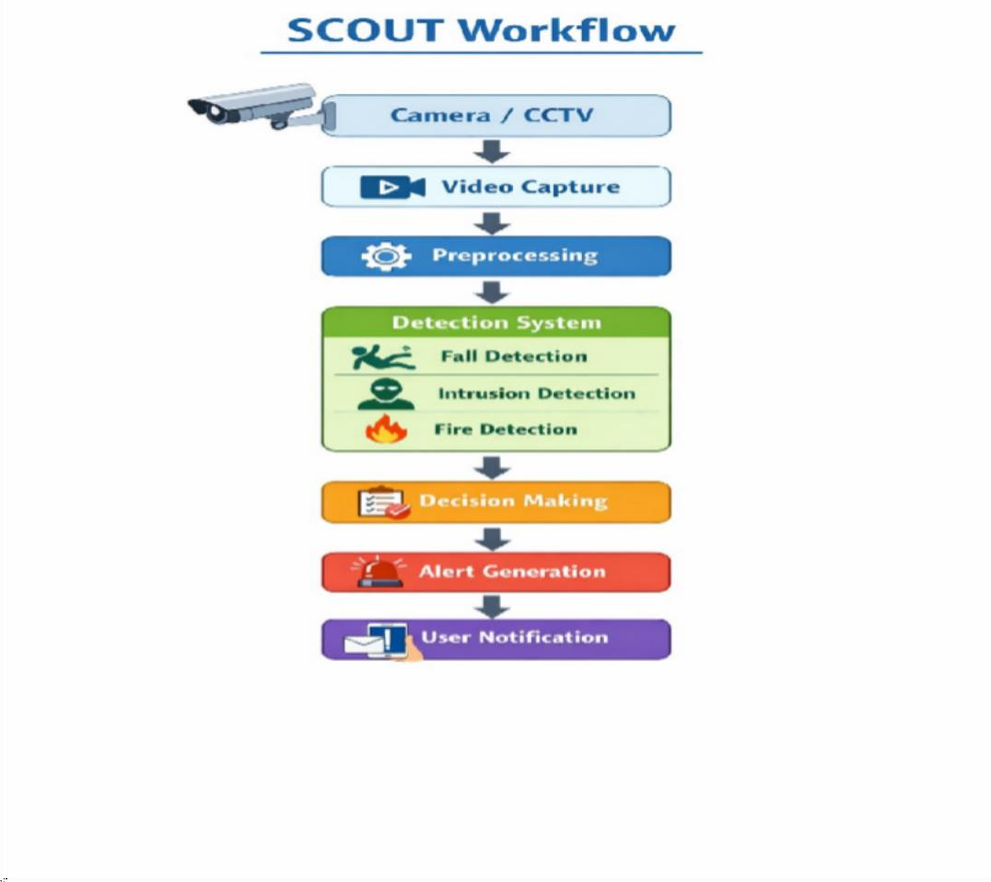

Fig 3.1: SCOUT Detection Pipeline

FALL DETECTION USING TEMPORAL ANALYSIS

Fall detection is an important part of the SCOUT system, particularly to promote the safety of the elders who live alone. The system recognizes falls on the basis of human motion patterns over successive video frames instead of basing this on single-frame analysis. Such temporal knowledge allows the system to embrace the dynamic posture changes, which is fundamental in the accuracy of detecting fall occurrences.
To do it, the system uses Long Short-Term Memory (LSTM) networks, a particular type of recurrent neural network, created to work with the sequential data. The LSTM model uses a series of frames as input and learns time dependencies of human motion. It refers to falling patterns, including the sudden loss in balance, quick downward movement, or sudden change in the postures that are usually linked to falls.
Besides checking through time, a pose-based review is also included in order to enhance accuracy of detection. In case of unclear cases, ambiguous human pose landmarks are determined with a MediaPipe-style pose estimator. All the important measurements, like torso inclination angle (□), calculated based on hip and shoulder marks, hip-to-shoulder distance, landmark confidence scores, and centroid velocity, are obtained. Centroid velocity is found as the change of body center in frames.
These characteristics are then sent to a Random Forest classifier (50 trees) that aids the differentiation of actual falls and regular Activities of Daily Living (ADLs). This compromise system will minimize false positives and increase the overall reliability of the system.

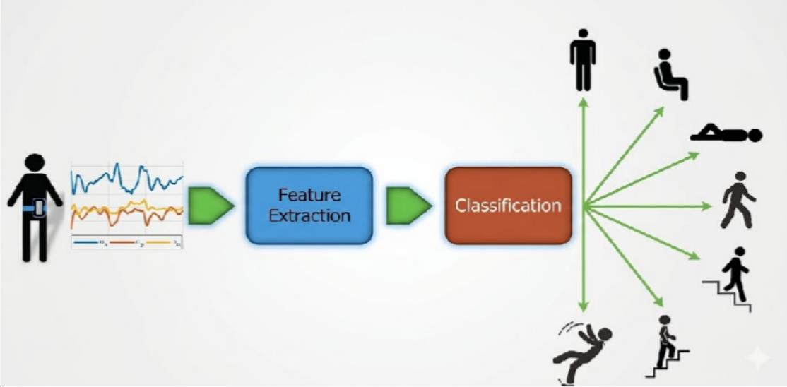

Fig 3.2: Flow of fall detection model

INTRUSION DETECTION USING YOLO v8 OBJECT DETECTION

Intrusion detection is a key part of the SCOUT system. Its goal is to find people who are not allowed to be in a monitored area or who seem suspicious. The system uses YOLOv8 (You Only Look Once version 8), a cutting-edge deep learning-based object detection algorithm that works best in real time, to find intruders.
YOLOv8 breaks each video frame into a grid and guesses bounding boxes and class probabilities for objects it finds. It can tell the difference between different types of objects, like people, animals, and other important things in the scene. The system figures out if the person it found is expected (known) or a possible intruder by looking at these detections over and over again.

The system can use contextual filtering, like time of day, movement patterns, and region-based monitoring, to help people make better decisions. This helps tell the difference between normal household activity and behavior that seems suspicious. For instance, unexpected movement in restricted areas or at odd times can be seen as a possible intrusion.
YOLOv8 is particularly suitable for surveillance systems due to its:

- High detection speed, enabling real-time processing of video streams

- Accurate object localization, ensuring precise identification of individuals

- Low computational overhead, making it efficient for edge-based deployment

These characteristics allow SCOUT to perform reliable and efficient intrusion detection, ensuring timely alerts and improved home security.
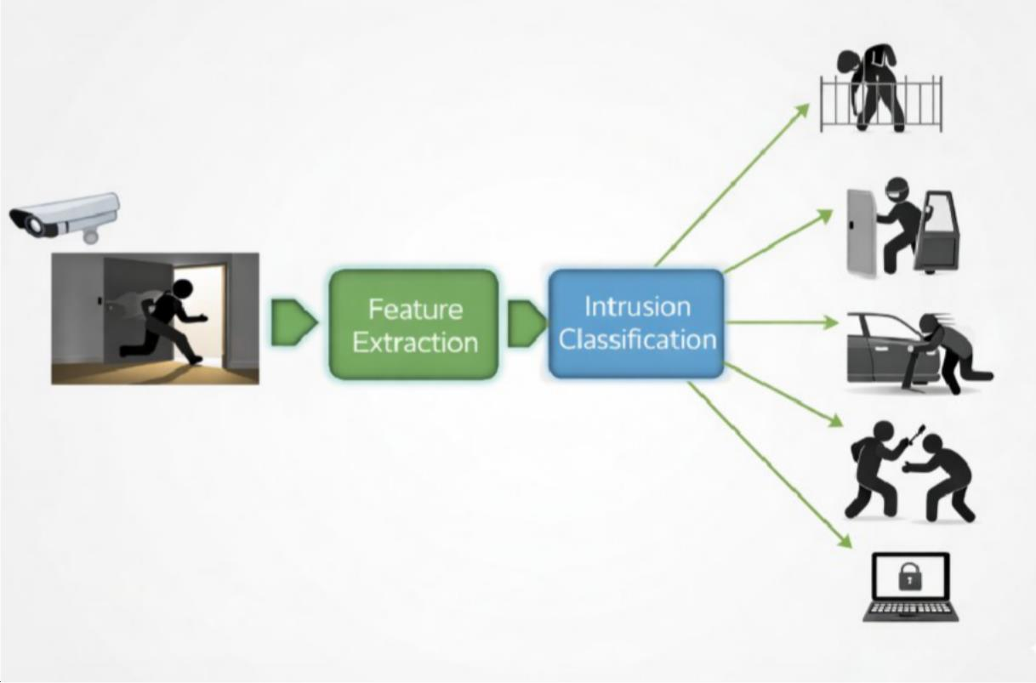
\

Fig 3.3: Flow of intruder detection model

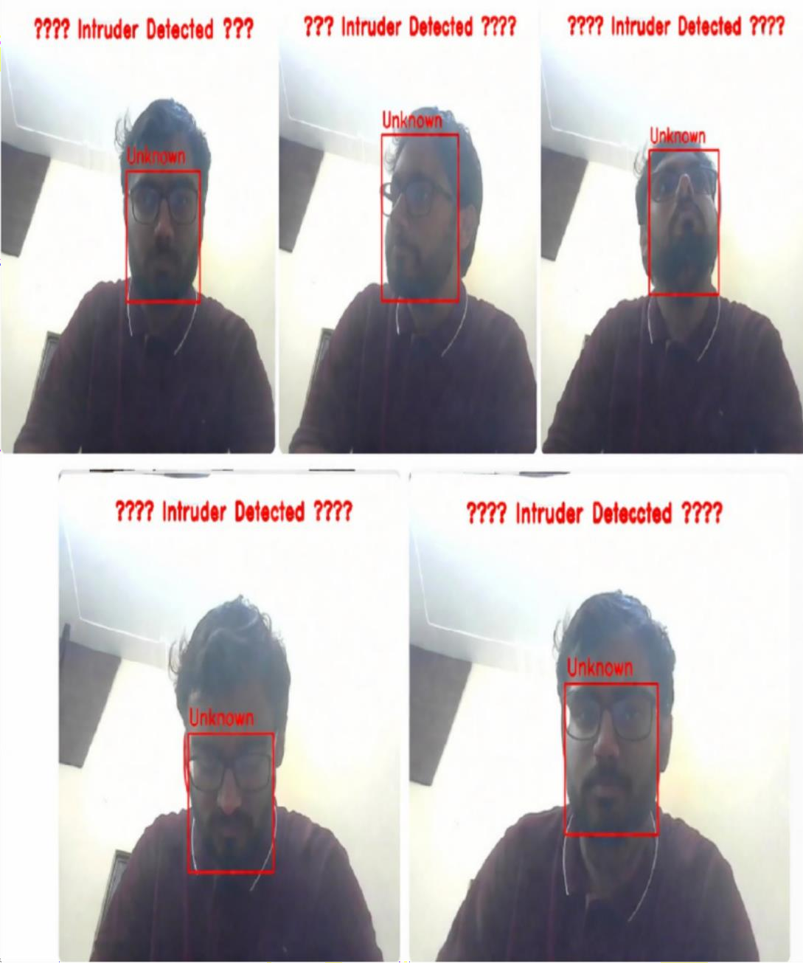

Fig 3.4: Intruder Detected Alert

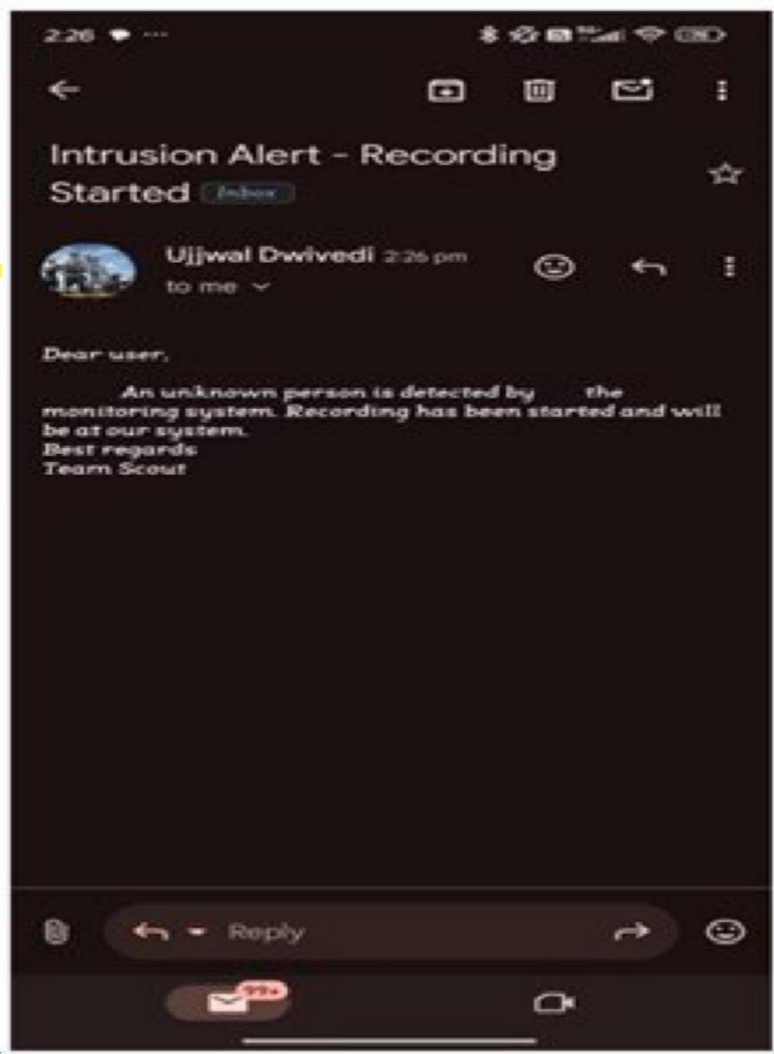

Fig 3.5: Intruder Detection Alert message

FIRE DETECTION Using YOLO v8 and CNN based detection modules

The SCOUT system has a special fire hazard detection module that can find flames and smoke in real time. This makes the home safer overall. This module uses Convolutional Neural Networks (CNNs), which are very good at finding spatial features in images and recognizing complicated visual patterns.
The CNN model learns from a wide range of fire and smoke datasets that include different situations, like fires inside and outside, and smoke in different lighting and weather conditions. When the system is running, it looks at each video frame to find unique traits of fire, such as color patterns (red, orange, and yellow hues), changes in texture, and the way flames and smoke move.
The system looks at both spatial and temporal features to make it more robust. This lets it tell the difference between real fire hazards and things that look like them, like bright lights or reflections. This makes it less likely that false alarms will happen and makes detection more reliable.
As soon as the system sees a possible fire or smoke event, it sends out an alert and lets the user know through the mobile interface. The response is meant to be quick so that users can act quickly to stop things from getting worse.
Finding fire hazards early is very important for protecting people and property. By integrating CNN-based fire detection with real-time alert mechanisms, SCOUT provides an effective and proactive solution for fire safety monitoring in smart home environments.

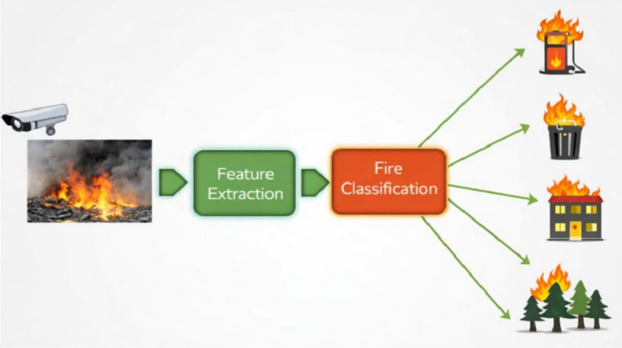

Fig 3.6: Flow of fire detection model

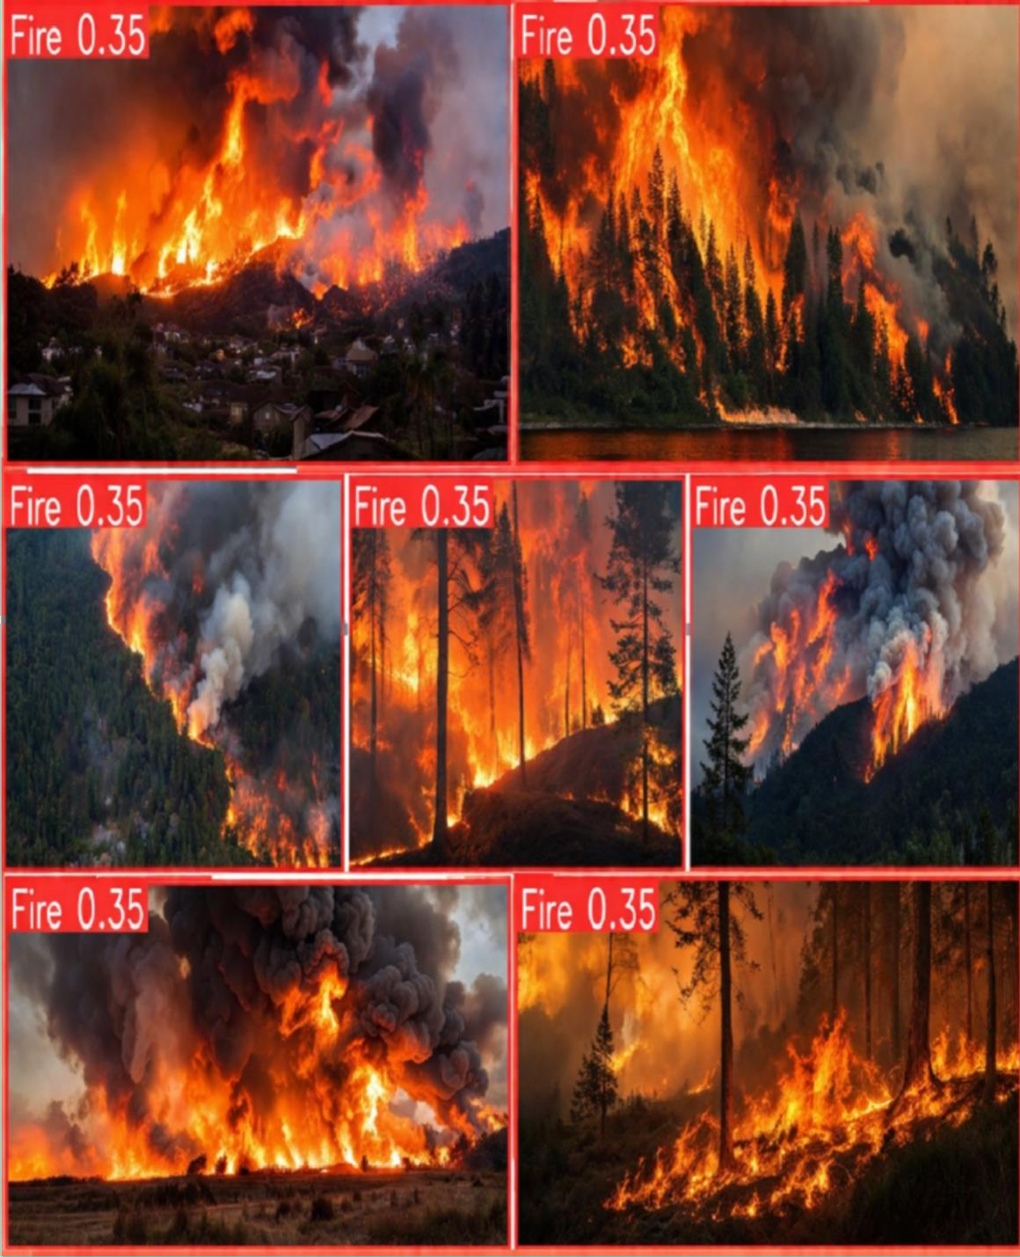

Fig 3.7: Fire Hazard Alert by YOLOv8n

YOLO v8 Model Architecture

YOLOv8n is used by SCOUT to identify individuals in video streams as it is fast and efficient and can therefore be very useful in high-speed video processing. This structure contains a backbone that captures visual information and transmits the signal through the network with no additional complexity than needed. It also includes a neck portion that incorporates the semantic information from the lower detail, spatial information from the higher detail to allow individual identification of people regardless of how far they are from the camera or where the camera is positioned; and a detection head that is anchor-free fully configured to calculate the object coordinates, objectness and classification probability for each identified object, reducing computational needs and increasing accuracy. Therefore, YOLOv8n allows for fast frame-to-frame analysis and fast and accurate person tracking which are both key components of detecting a fall. As such, SCOUT uses YOLOv8n outputs with posture-based heuristics and temporal smoothing to quickly and accurately detect a fall.

  - ALERT AND NOTIFICATION SYSTEM

Once an abnormal event such as intrusion, fall, or fire is detected, the system immediately generates alerts. These alerts are transmitted to the user through mobile notifications or email alerts. The notification may include details such as the type of detected event and a snapshot from the camera feed.
The system might also keep recordings of events for later study. You can use optional cloud storage to keep track of event history, but the main processing stays on the edge device to keep your information private.

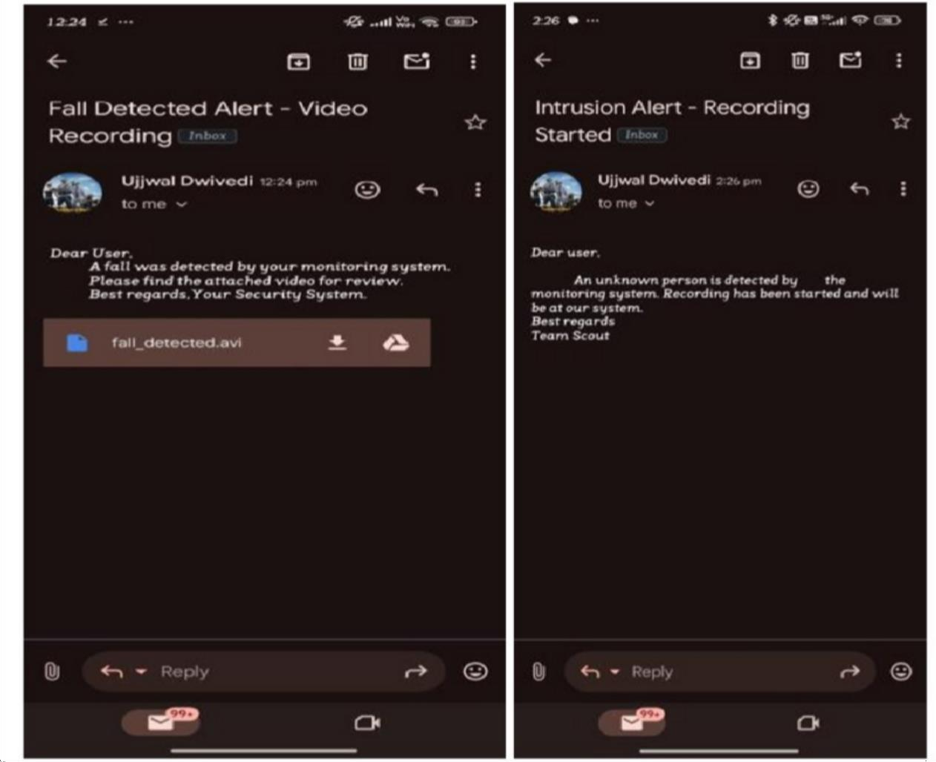

Fig 3.8 : Photos or videos showcasing real-time detection

CHAPTER 4 RESULTS AND DISCUSSION

Experimental Setup

The SCOUT system was built using Python and computer vision and deep learning frameworks like OpenCV and TensorFlow. It looks at real-time video streams from surveillance cameras and analyzes them frame by frame to find strange events, such as break-ins, falls, and fire risks.
The testing setup had a surveillance camera for video input, a local edge device for processing, trained machine learning models for detection tasks, and a notification system for sending alerts. The system was tested in different situations, like normal activities, falls, attempts to break in, and fires, to see how well it worked.

Fall Detection Results

The fall detection module employs temporal motion analysis via an LSTM-based model to examine human posture and movement across various video frames.

Table 4.1 Fall Detection Performance

Metric Observation Interpretation

Train Loss Decreases from ~1.2 to ~0.2
Model is learning and reducing training error

Validation Loss
Decreases from ~1.4 to ~0.5 with slight fluctuations
Model generalizes well; no significant overfitting

Metric Observation Interpretation

Precision
Increases from ~0.60 to

~0.95
Model is reducing false positives and improving accuracy

mAP@0.5 Increases from ~0.63 to ~0.97
Overall detection performance is very high

Graph 4.1 Fall Detection Result Graph
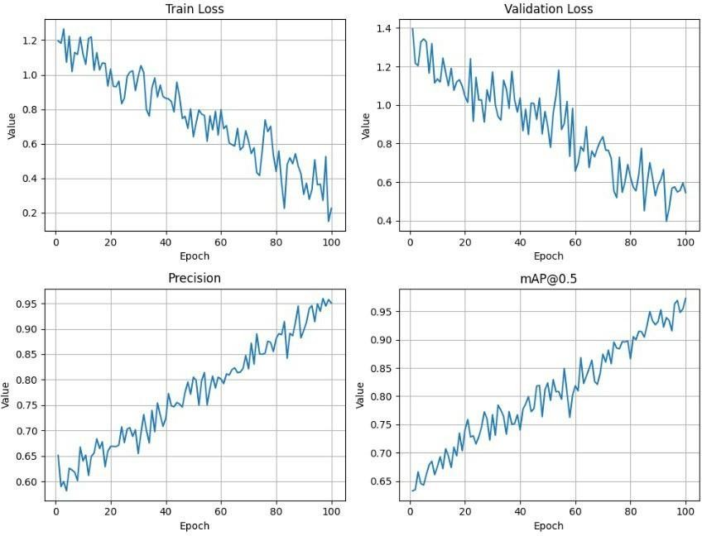

The results show that the model can tell the difference between normal daily activities and falls. This cuts down on false fall alerts by a lot, which makes the system reliable for monitoring older people.

Intrusion Detection Results

The YOLO-based object detection algorithm in the intrusion detection module finds people and things in real time.

Table 4.2 Intrusion Detection Performance

Scenario | Detection Result | Accuracy
Single person entering monitored area | Detected correctly | 96%
Multiple individuals present | Detected correctly | 94%
Pet movement in room | Correctly ignored | 92%
Normal household activity | Classified as normal | 93%

Graph 4.2 Intrusion Detection Accuracy
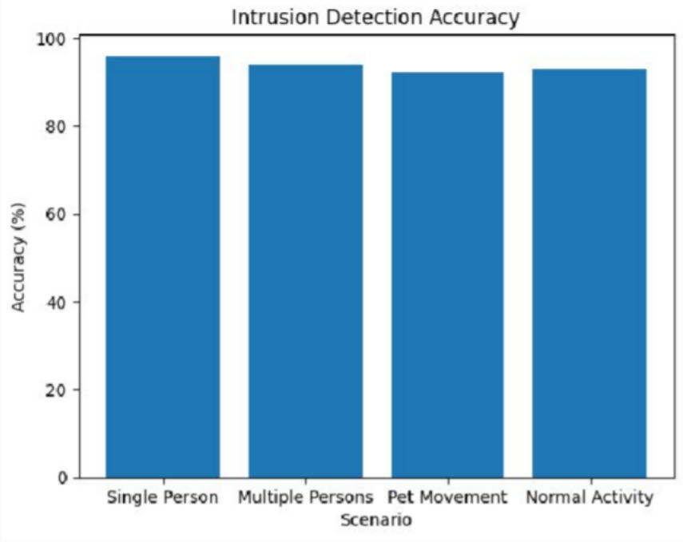

The results show that the object detection model works well at finding people while reducing false alarms caused by pets or normal movement in the environment.

Fire Detection Results

To find flames and smoke patterns in video frames, the fire detection module uses Convolutional Neural Networks (CNNs).

Table 4.3 Fire Detection Performance

Metric Observation Interpretation

Train Loss Decreases from ~1.2 to ~0.35
Model is learning fire and smoke features effectively

Validation Decreases from ~1.3 to ~0.5 with Model generalizes well but shows

Metric | Observation | Interpretation
Loss | slight fluctuations | minor fluctuations

Precision
Increases from ~0.65 to

~0.90
Model improves in correctly detecting fire events

mAP@0.5 Increases from ~0.70 to ~0.92
Overall detection performance is good and reliable

Graph 4.3 Fire Detection Accuracy
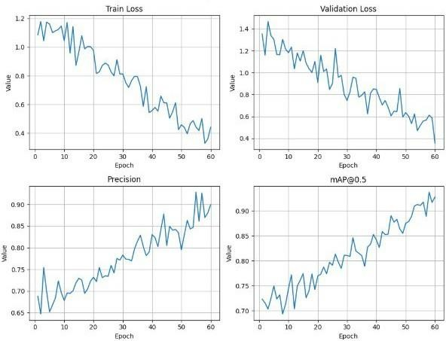

The findings indicate that the CNN model proficiently detects flame and smoke patterns in real time, facilitating prompt fire hazard identification..

Overall System Performance

Table 4.4 Overall SCOUT System Performance Detection Module Accuracy
Intrusion Detection 94%

Fall Detection 95%

Detection Module Accuracy

Fire Detection 95%

Discussion

The experimental results show that the SCOUT system can use computer vision and machine learning to find many different types of emergencies. A smart home can be fully monitored with a single system that includes intrusion detection, fall detection, and fire recognition.
One of the main benefits seen during testing is the edge-based processing architecture. This cuts down on response time a lot because the video analysis is done on the spot instead of relying on cloud servers. This method also protects privacy by limiting the sharing of private video data.
The system works well in controlled settings, but things like bad lighting, the placement of the camera, and objects being partially blocked may make detection less accurate. Future improvements could include better model training and the ability to use more than one camera at a time.
Bigger datasets to make the system more stable. The results show that SCOUT is a trustworthy, scalable, and privacy-protecting AI-based monitoring system that can make smart home security and monitoring the safety of older people better.

CHAPTER 5 CONCLUSION AND FUTURE SCOPE
  - CONCLUSION

The Smart Camera Observation & Unusual Tracking System (SCOUT) was made to be an intelligent monitoring system that uses AI and computer vision to make homes safer and more secure. The main goal of the project was to make a complete system that could find many different types of emergencies, such as intrusions, falls, and fire hazards, by analyzing video in real time.
The proposed system effectively amalgamates multiple machine learning models to autonomously analyze surveillance camera feeds and detect anomalous events. Object detection techniques help find people and possible intrusions, temporal motion analysis helps find falls, and convolutional neural networks help find patterns of smoke and fire. The system uses a combination of these technologies to create a single monitoring platform that can handle many different safety threats.
The SCOUT system's edge-based processing architecture is one of its best features. It analyzes video data locally instead of sending it to cloud servers all the time. This method keeps user privacy while cutting down on response time by a lot.
The system is also made to be non-intrusive, so you don't need to wear anything and it's great for keeping an eye on older people and smart home settings.
The system works well at finding strange events and not setting off false alarms, as shown by the experiments. SCOUT can be a reliable and scalable smart monitoring solution because it has multiple detection modules that work together. The project has also helped academic innovation by creating a research paper and a patent that has been published. This shows how important it is for both research and practical use.

The SCOUT system shows how artificial intelligence and computer vision can be used to make smart surveillance systems that can make homes safer, help care for the elderly, and speed up emergency response.
  - FUTURE SCOPE

The proposed SCOUT system works well to find different safety threats, but it could do better. There are many chances to make things even better and improve them.
One possible improvement is the addition of multi-camera systems, which would let the system watch over larger areas and fix problems with object occlusion or limited camera coverage. In the future, the system could also use more advanced pose estimation models to make fall detection more accurate in more complicated situations.
Another possible improvement is to connect Internet of Things (IoT) devices to SCOUT so that it can talk to other smart home devices like smart alarms, automatic door locks, or fire suppression systems. This would let the system automatically take steps to protect itself in case of an emergency.
Future research could also look into ways to make the system work better in tough environments, like when there isn't much light, when there are a lot of things in the way, or when there are a lot of people around. Training the models on bigger and more varied datasets could make them even better at finding things and more reliable.
Finally, the SCOUT system could be turned into a cloud-assisted intelligent monitoring platform that uses edge processing and cloud-based analytics to look at data over time and predict safety issues. Such improvements would make the system more scalable and allow it to be used in more places, like hospitals, office buildings, and smart cities.
In conclusion, the SCOUT system is a solid base for making smart safety monitoring systems and has a lot of room for more research and use in the real world.

REFERENCES
- A. Chelli and M. Patzold, “A Machine Learning Approach for Fall¨ Detection and Daily Living Activity Recognition,” IEEE Access, 2019.
- L. Mart´ınez-Villasenor et al., “UP-Fall Detection Dataset: A Multimodal˜ Approach,” Sensors, 2019.
- Ultralytics, “YOLOv8 documentation,” 2023. [Online]. Available: https:
//docs.ultralytics.com

- J. Gutierrez et al., “Comprehensive review of vision-based fall detection,”´ Sensors, 2021.

- J. Redmon et al., “You Only Look Once: Unified, Real-Time Object Detection,” CVPR, 2016.
- G. Jocher et al., “YOLOv8: New state-of-the-art object detection architecture,” Ultralytics, 2023.
- R. Girshick, “Fast R-CNN,” Proc. ICCV, 2015.

- S. Ren, K. He, R. Girshick, and J. Sun, “Faster R CNN: Towards real-time object detection with Region Proposal Networks,” Proc. NeurIPS, 2015.
- K. S. Rawat and D. Singh, “Vision-based fall detection using human posture and motion features,” Proc. ICCCN, 2020.
- U. Asif et al., “Privacy preserving human fall detection using video data,” Proc. ML Research, 2020. [11] T.-Y. Lin et al., “Focal Loss for Dense Object Detection,” Proc. ICCV, 2017.
- K. He, X. Zhang, S. Ren, and J. Sun, “Deep residual learning for image recognition,” Proc. CVPR, 2016.
- A. Krizhevsky, I. Sutskever, and G. Hinton, “ImageNet classification with deep convolutional neural networks,” NeurIPS, 2012.

- A. Toshev and C. Szegedy, “DeepPose: Human pose estimation via deep neural networks,” CVPR, 2014.
- X. Sun et al., “Integral Human Pose Regression,” ECCV, 2018.

- S. Hochreiter and J. Schmidhuber, “Long short term memory,” Neural Computation, 1997.

APPENDIX 1

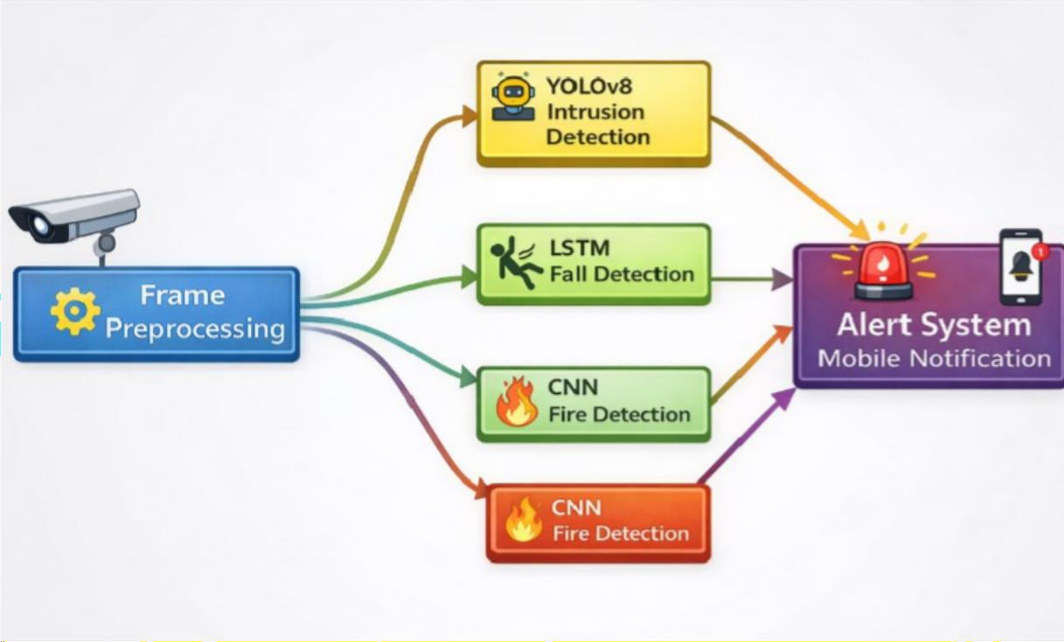

Figure A: SCOUT System Architecture

Fall Detection Pseudo code

1: Input: Video frames stream {Ft}, thresholds rth,α,T,τ

2: Initialize sliding window buffer W of size T, pre-buffer for recording 3: for each frame Ft do
4: Detections ← detect persons(Ft) 5: if no detections then continue

6: end if

7: Select primary detection B = (x1,y1,x2,y2), compute r,η,c

8: It ← (r > rth ∧ η > α)
9: append It to W

10: if ^{P}W ≥ τ then

11: if pose enabled then

12: features ← extract pose features(Ft)

13: if pose classifier.predict(features) == fall then 14: trigger alert()
15: end if

16: else

17: trigger alert()

18: end if

19: end if

20: end for

PATENT

Status : Published Application No.202511000014 A Publication Date : 17/01/2025
PROOF OF PUBLICATION:


RESEARCH PAPER

Status : Published and Presented at ICCSC2026 held at ABESEC

PROOF OF SUBMISSION/ACCEPTANCE/PUBLICATION:



PLAGIARISM REPORT

scout

ORIGINALITY REPORT

14 %
12%
12% 6%

SIMILARITY INDEX
INTERNET SOURCES
PUBLICATIONS
STUDENT PAPERS

PRIMARY SOURCES

www.groundai.com
1
Internet Source

xieenze.github.io
2
Internet Source

3 S.A.M Rizvi, Pankaj Agarwal. "A time efficient algorithm for finding longest common
subsequence from two molecular sequences", 2007 IEEE 33rd Annual Northeast Bioengineering Conference, 2007
Publication

4 Bhim Singh. "Multipulse AC–DC Converters for Improving Power Quality: A Review", IEEE
Transactions on Power Electronics, 01/2008
Publication

mcg.uia.no
5
Internet Source

www.mdpi.com
6
Internet Source

www.mva-org.jp
7
Internet Source

Submitted to Coventry University
8
Student Paper

9 Submitted to Colorado Technical University Online
Student Paper

Submitted to City University of Hong Kong
10
Student Paper
1%
1%
1%

1%

1%
1%
1%
1%
1%

<1%

salford-repository.worktribe.com
11
Internet Source

web.archive.org
12
Internet Source

13 Xuchao Huang, Yao Zhang, Hao Li, Quan An, Guancheng Zhao. "SLiG-Net: A joint pose
optimization network for space robot grasping under low-light conditions in on-orbit operations", Acta Astronautica, 2025
Publication

www.byteplus.com
14
Internet Source

d197for5662m48.cloudfront.net
15
Internet Source

machinelearningarchitect.com
16
Internet Source

www.coursehero.com
17
Internet Source

ieeexplore.ieee.org
18
Internet Source

www.etran.rs
19
Internet Source

20 Rei Egawa, Abu Saleh Musa Miah, Koki Hirooka, Yoichi Tomioka, Jungpil Shin.
"Dynamic Fall Detection Using Graph-Based Spatial Temporal Convolution and Attention Network", Electronics, 2023
Publication

www.frontiersin.org
21
Internet Source

- Asali, Ehsan. "Spatiotemporal Multimodal Representation Learning for Activity
<1%
<1%
<1%

<1%
<1%
<1%
<1%
<1%
<1%
<1%

<1%
<1%

Understanding and Behavior Monitoring.", University of Georgia
Publication

- Grigorios Kyriakopoulos, Stamatios Ntanos, Theodoros Anagnostopoulos, Nikolaos
Tsotsolas, Ioannis Salmon, Klimis Ntalianis. "Internet of Things (IoT)-Enabled Elderly Fall Verification, Exploiting Temporal Inference Models in Smart Homes", International Journal of Environmental Research and Public
Health, 2020
Publication

- Kirti Aggarwal, Anuja Arora, Zahid Akhtar, Alessandro Bruno. "Computational
Intelligence for Connective Cognition Networks - Advances and Applications", Routledge, 2025
Publication

ijimai.org
25
Internet Source

link.springer.com
26
Internet Source

- Dhirendra Kumar Shukla, Shabir Ali, Sandhya Sharma. "Artificial Intelligence and
Sustainable Innovation - Volume 2", CRC Press, 2026
Publication

- Tsepo Constantinus Kolobe, Chungling Tu, Pius Adewale Owolawi. "A Review on Fall
Detection in Smart Home for Elderly and Disabled People", Journal of Advanced Computational Intelligence and Intelligent Informatics, 2022
Publication

<1%

<1%

<1%
<1%
<1%

<1%

Exclude quotes Off Exclude bibliography Off
Exclude matches Off

